Standardisierte Klassenarbeit zu New Highlight 2 nach Unit 2

From Germany to England

Listening:

Nico & Sarah (Track 3)

Reading:

Colchester castle

Writing:

A poster about England and Germany

Writing a postcard

Wordpower

Vokabeln (Transportmittel)

Structures:

Steigerungsformen

Listening

Task 1a: Listening – Nico & Sarah (Track 3 – 1:53) |  | 3 p.
Look at the picture and listen to Nico and Sarah.
Which places and people are they talking about? Put a .
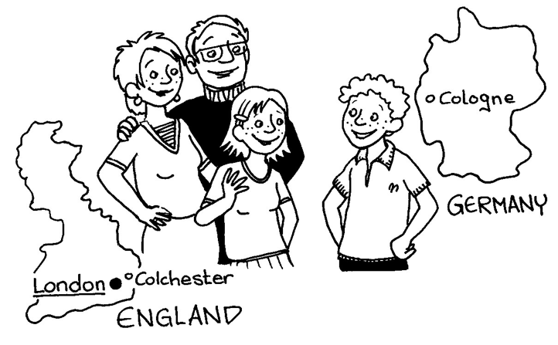

1 Nico   2 Cologne (Köln)   3 Colchester   4 Krefeld  | 5 London   6 Sarah   7 Sarah’s mum and dad   8 Nico’s mum and dad 

Task 1b: Listening – Nico & Sarah (Track 3 – 1:35) |  | 4 p.
Listen again. Right or wrong? Put a .
 |  | right | wrong
1 | Nico is in Germany this week. | ❑ | ❑
2 | Colchester is 80 miles from London. | ❑ | ❑
3 | Cologne is much bigger than Colchester. | ❑ | ❑
4 | Nico thinks that Colchester is boring. | ❑ | ❑
5 | Sarah’s mum is German. | ❑ | ❑
6 | Sarah’s mum has a brother. He lives in Germany and his name is Dieter. He’s Sarah’s uncle Dieter. | ❑ | ❑
7 | Sarah is one year older than Nico. | ❑ | ❑
8 | Sarah thinks it’s great that Nico is in Colchester this week. | ❑ | ❑

Task 1c: Listening – Nico & Sarah (Track 3 – 1:35) |  | 7 p.
Listen again. Make the sentences. (Nur eine Antwort ist jeweils richtig.)

1 Nico is a German  2 Nico’s cousin Sarah lives  3 Nico is in Colchester  4 He’s with Sarah and  5 Cologne is much bigger  6 But Nico thinks that  7 Nico is one year older  8 He thinks that Sarah | a) her mum and dad.  b) than his cousin Sarah.  c) boy from Cologne.  d) is great.  e) in Colchester in England.  f) than Colchester.  g) Colchester is nice.  h) this week.

2 | ____ | 3 | ____ | 4 | ____ | 5 | ____ | 6 | ____ | 7 | ____ | 8 | ____

Reading

Colchester castle

Sarah is an English girl. She lives in Colchester, a town in England. Sarah’s mum is German and Sarah has a German cousin. He lives in Cologne and his name is Nico.

It was the summer holidays and Nico was in Colchester. On Saturday afternoon, Sarah and her mum and Nico were in town. “Let’s have a nice cup of tea,” said Sarah’s mum. “Look, there’s a cafe.” “Oh, mum!” said Sarah. “Tea is boring! Nico, I know something more exciting. We can go to Colchester castle.” “Sorry, what’s a castle?” said Nico. “Eine Burg,” said Sarah’s mum. “Come on, Nico,” said Sarah. “See you later, mum.”

Sarah and Nico went to Colchester castle. “It’s very old,” said Nico. “Yes, it is,” said Sarah. “Come on. Let’s go in.” Nico thought the castle was great. There were lots of old things in the castle. Then the guide said, “There’s an old tunnel under the castle. Who wants to see the tunnel?” “Me!” said Sarah. “And me!” said Nico. Soon they were at the tunnel. “It’s very big,” said Nico. “Yes, you can stand in it,” said the guide. “But it’s cold here,” said Sarah. “Come on, Nico. Let’s go to the cafe now. I want a nice cup of hot tea.”

Task 2a: Colchester castle |  | 3 p.
Read the story. Put the pictures A–F in the right order.

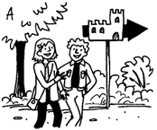 | 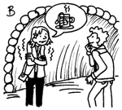 | 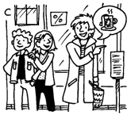
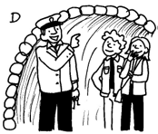 | 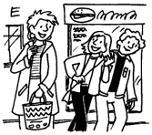 | 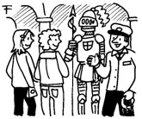
1 _____ 2 _____ | 3 _____ 4 _____ | 5 _____ 6 _____

Task 2b: Colchester castle |  | 4,5 p.
Which is right? Put a .

1 | Nico is Sarah’s …
 | a)  | brother. | b)  | cousin. | c)  | mum.
2 | On Saturday afternoon, Sarah, her mum and Nico were in …
 | a)  | Colchester. | b)  | Cologne. | c)  | Germany.
3 | Sarah’s mum wanted to have a cup of tea in …
 | a)  | a café. | b)  | Colchester castle. | c)  | the river.
4 | Sarah said, “Come on, Nico. I know something more …
 | a)  | boring. | b)  | expensive. | c)  | exciting.
5 | Sarah and Nico were in Colchester castle. Nico thought the castle was …
 | a)  | small. | b)  | boring. | c)  | great.
6 | There’s an old … under Colchester castle.
 | a)  | tunnel. | b)  | river. | c)  | guide.
7 | You can … in the tunnel.
 | a)  | crawl. | b)  | stand. | c)  | swim.
8 | Sarah thought the tunnel was …
 | a)  | cold. | b)  | old. | c)  | big.
9 | At the end of the story, Sarah wanted to have a …
 | a)  | nice glass of water. | b)  | cup of cold tea. | c)  | cup of hot tea.

Writing
Task 3a: A poster |  | 9 p.
Your English teacher wants to have a poster about England and Germany. Lots of
things in England are different. Finish the sentences.
England and Germany
How big is Germany? How big is England?
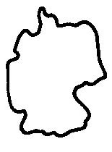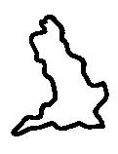
Germany is (1) ______________________ than England.

Time in Germany and England is different.
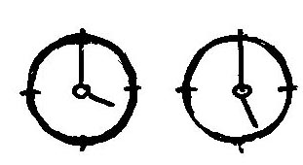
When it’s four o’clock in England, it’s (2) ___________________________.

Roads in Germany and England are different.
In Germany you drive on the right. But in
England you (3) ______________________________.

Do people use kilometres in England?
No, they don’t! In Germany people use kilometres, but
in England (4) _______________________________.

How can you go to England?
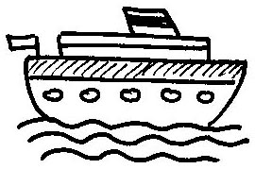
You can go to England by (5) ______________, or by (6) ________________,
or you can go by train through the (7) _________________________________.

Do people in England speak German?
No, they don’t! People in Germany
(8) ______________________________________________ but (9)
___________________________________________________________________!

Task 3b: Writing |  | 10 p.

Nico is from Cologne in Germany but this week he’s in Colchester in England. He’s visiting his English cousin. You’re Nico. Finish the postcard to your English teacher in Cologne. Use Nico’s ideas.

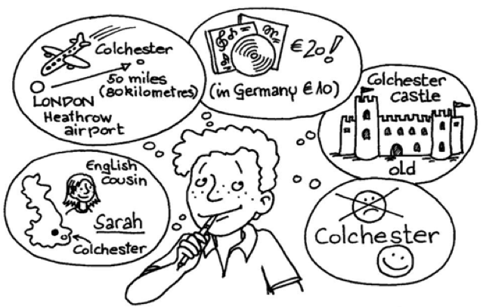
Dear Ms Ullrich,
I’m on holiday (1) _______________________. I’m visiting
(2) _________________________________________. Her name (3)_____________________. I went to
(4) _______________________________.
It was very fast. Sarah and her mum and dad were at the airport. Colchester is (5) ___________________ London. Colchester has some nice shops, but CDs in England are (6) __________________________. On Saturday, I went to (7) ____________________________ with Sarah. It was very (8) ______________. I like Colchester.
Colchester isn’t (9) _______________________. It’s very
(10) ___________________.
See you soon,
Nico Hansmann

Wordpower

Task 4a: Wordpower |  | 2,5 p.
Look at the pictures. Finish the sentences.

 |  |  |  |  |  |  |  | 
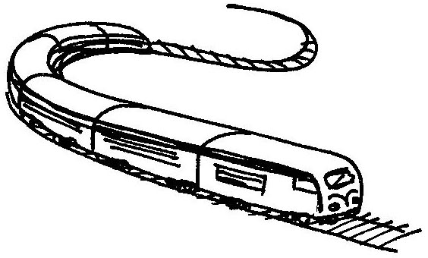 |  |  |  | 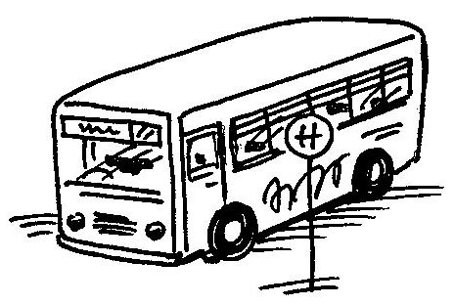 |  |  |  | 
 |  | 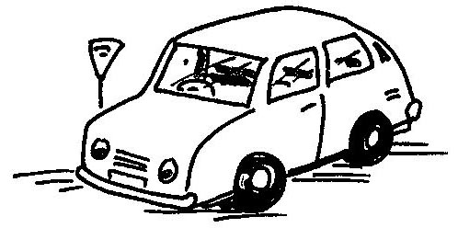 |  |  |  | 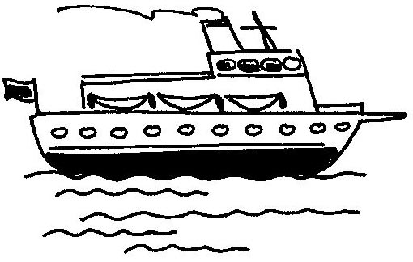

1 | Tom | I go to school by _____________________________.
2 | Ms Schmidt | I live and work in Frankfurt am Main. I often go to business meetings in London. I go by ________________________. It’s very fast.
3 | Susan | My mum and dad and I go on holiday every year. We go from
 |  | England to France by ___________________________.
4 | Jake | I’m a Manchester United fan. I go to all their matches. I usually
 |  | go by ___________________________.
5 | Mr Jones | I’m a teacher. I go to school every day by __________________.

Words to help you
business meeting = Geschäftsbesprechung

Structures
Task 5a: |  | 3 p.
Pick the right word. Put a .
1 | Elephants are … than cats.
 | bigger | smaller
2 | This CD is £10 but that CD is £15. This CD is … than that CD.
 | cheaper | more expensive
3 | Sarah is … than her mum.
 | older | younger
4 | Harry likes football but he doesn’t like shopping in town.  Harry thinks that football is … than shopping.
 | more boring | more exciting
5 | It’s 50 miles from Colchester to London – that’s 80 kilometers.  Kilometers are … than miles.
 | longer | shorter
6 | Nico doesn’t like school uniforms in England.  He thinks that jeans and a T-shirt are … than a uniform.
 | better | worse

Task 5b: |  | 4 p.
Say it in English!
1 Das rote Auto ist teuerer als das blaue Auto.
The red car is _______________________ than the blue car.
2 Der Rhein ist länger als der kleine Fluss in Colchester in England.
The Rhine is _______________________ than the small river in Colchester in England.
3 Diese CD ist besser als jene CD.
This CD is _________________________ than that CD.
4 Fußball ist aufregender als Schwimmen.
Football is _________________________ than swimming.

Task 5c: Past progressive |  | 5 p.
Put the missing words in the list.

bad  (2) ________________  boring  cheap  exciting  (6) ________________  fast  good  long  (10) _______________ | →  →  →  →  →  →  →  →  →  → | (1) ___________________  bigger  more boring  (4) ___________________  (5) ___________________  more expensive  faster  (8) ___________________  longer  smaller | →  →  →  →  →  →  →  →  →  → | worst  biggest  (3)_________________  cheapest  most exciting  most expensive  (7) _________________  best  (9) _________________  smallest

Ergebnisse

 |  | erreicht | möglich
LISTENING | Task 1a: |  | 3
LISTENING | Task 1b: |  | 4
LISTENING | Task 1c: |  | 7
READING | Task 2a: |  | 3
READING | Task 2b: |  | 4,5
WRITING | Task 3a: |  | 9
WRITING | Task 3b: |  | 10
WORDPOWER | Task 4a |  | 2,5
Structures | Task 5a: |  | 3
Structures | Task 5b: |  | 4
Structures | Task 5c: |  | 5
 | ∑ |  | 55

ca. Notengrenzen

Note | % | ab … Punkten
sehr gut | 90 | 49
gut | 75 | 41
befriedigend | 60 | 33
ausreichend | 45 | 25
mangelhaft | 20 | 11

Note

Datum, Unterschrift Klassenlehrer

Unterschrift d. Erziehungsberechtigten

LISTENING | Task 1a: | 3
LISTENING | Task 1b: | 4
LISTENING | Task 1c: | 7
READING | Task 2a: | 3
READING | Task 2b: | 4,5
WRITING | Task 3a: | 9
WRITING | Task 3b: | 10
WORDPOWER | Task 4a: | 2,5
Structures | Task 5a: | 3
Structures | Task 5b: | 4
Structures | Task 5c: | 5
 | ∑: | 55
 | Grade:

Listening Nico and Sarah

Nico
Hello. I’m Nico. I’m a boy and I’m 12 years old. Can you see me in the picture? I’m from Germany. I live in Köln but in England people don’t say ‘Köln’. They say ‘Cologne’. This week I’m not in Germany. I’m in England. I’m in Colchester. It’s a town in England. It’s 50 miles – that’s 80 kilometres – from London. I’m with my cousin Sarah. She lives in Colchester with her mum and dad. Colchester isn’t a big town. Cologne is much bigger than Colchester. But Colchester isn’t boring. It’s nice. And my cousin Sarah is great! I like Sarah and I like Colchester.

Sarah
Hi. My name is Sarah. I’m a girl and I’m 11 years old. Can you see me in the picture? My mum and dad are in the picture too. Can you see them? We live in Colchester. My mum is German. Her brother lives in Cologne. His name is Dieter and so he’s my Uncle Dieter. I have a German cousin too. His name is Nico. Nico is in Colchester this week. Nico is 12 years old. I’m 11 years old, so Nico is one year older than me. He’s nice. I like Nico. It’s great that he’s in Colchester this week.
3 Punkte
1a) 1 Nico, 2 Cologne (Köln), 3 Colchester,
5 London, 6 Sarah, 7 Sarah’s mum and dad,

1b) 1 wrong
2 wrong
3 right
4 Punkte
4 wrong
5 right
6 right
7 wrong
8 right
7 Punkte
1c) 2 e), 3 h), 4 a), 5 f), 6 g), 7 b), 8 d)

Reading Colchester castle
3 Punkte
2a) 1 C), 2 E), 3 A), 4 F), 5 D), 6 B)

4,5 Punkte
2b) 1 b), 2 a), 3 a), 4 c), 5 c), 6 a), 7 b), 8 a), 9 c)

3 Writing A poster
3a)
1 bigger
2 five o’clock in Germany
3 drive on the left
9 Punkte
4 people use miles
5 plane
6 ship
7 tunnel
8 speak German
9 people in England speak English

A postcard from Colchester
3b

1 in Colchester
2 my English cousin
3 is Sarah
4 England (London/Heathrow airport) by plane
10 Punkte
5 50/fifty miles from
6 more expensive than in Germany
7 Colchester castle
8 old
9 boring
10 exciting/interesting/nice

4a Wordpower
1 bus
2 plane
2,5 Punkte
3 ship
4 train
5 car

5 Structures
5a) 1 bigger
2 cheaper
3 Punkte
3 younger
4 more boring
5 shorter
6 better

5b) 1 more expensive
4 Punkte
2 longer
3 letter
4 more exciting

5c
1 worse
2 big
3 most boring
4 cheaper
5 Punkte
5 more exciting
6 expensive
7 fastest
8 better
9 longest
10 small

