Standardisierte Klassenarbeit zu New Highlight 3 nach Unit 4

NORTHERN LIGHTS

Listening:

The Blackpool Illuminations (Track 5)

Reading:

Things to do in Blackpool

Writing:

Where I live

Wordpower

Vokabeln
me, you, him, her ... einsetzen
Offers - Angebote machen

Structures:

will-future
won’t

Listening

Task 1a: Listening – Two L.A. dreams (Track 5 – 2:26) |  | 3 p.
Listen to the radio programme. Put the pictures in the right order 1-6.

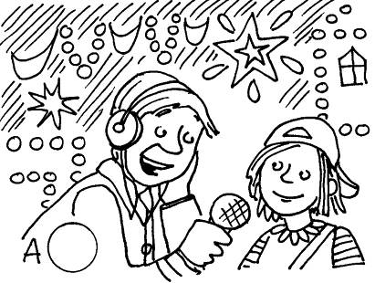 | 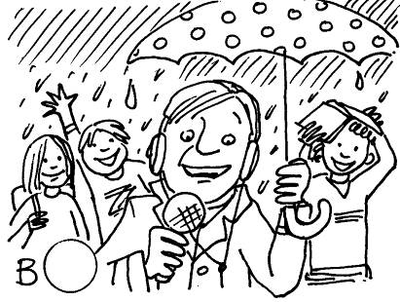 | 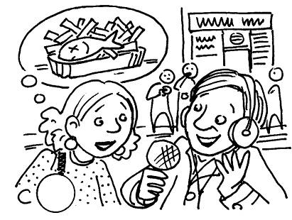
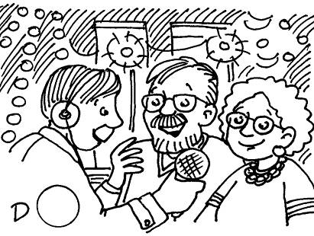 | 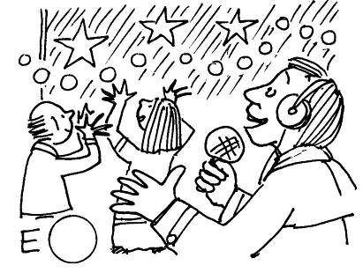 | 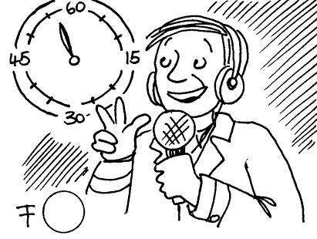

Task 1b: Listening – Two L.A. dreams (Track 3 – 2:34) |  | 2,5 p.
Listen again. Which is right – a), b) or c)? Put a .

1 | It’s … | a) | 6 o’clock in the morning.
1 | It’s … | b) | 4 o’clock in the afternoon.
1 | It’s … | c) | 8 o’clock in the evening.
2 | Today is the … day of the Blackpool Illuminations. | a) | first
2 | Today is the … day of the Blackpool Illuminations. | b) | second
2 | Today is the … day of the Blackpool Illuminations. | c) | last
3 | The man and his wife … | a) | are in Blackpool for the first time.
3 | The man and his wife … | b) | came to Blackpool for the first time last year.
3 | The man and his wife … | c) | come to see the lights every year.
4 | The teenage girl … | a) | isn’t here to see the lights.
4 | The teenage girl … | b) | thinks the lights are great.
4 | The teenage girl … | c) | thinks the lights are boring.
5 | The woman … | a) | thinks the lights are not a good idea.
5 | The woman … | b) | loves the lights.
5 | The woman … | c) | is eating some fish and chips.

Reading

THINGS TO DO IN BLACKPOOL
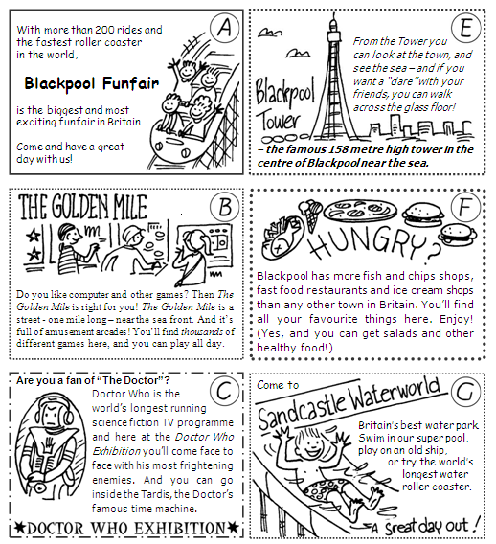
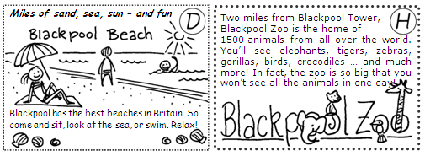

Task 2a: Match the teenagers and the activities. |  | 5 p.
The five teenagers below will all be on holiday in Blackpool. What will they do there?
- Read about the teenagers.
- Then look at “Things to do in Blackpool”.
- Find two activities for each teenager.
- Write the letters A-H in the boxes below.

 | Activity  1 | Activity  2 | The teenagers
1 |  |  | Thomas likes everything that has to do with animals. He also loves fast, exciting roller coasters. | 
2 |  |  | Kylie likes playing computer games. When she’s on holiday, she also likes eating lots of ice creams and her favourite hamburgers. | 
3 |  |  | Lalima wants to relax on her holiday – to sit near the sea, perhaps read a book and listen to music on her MP3 player. She also wants to see the time machine from her favourite TV programme. | 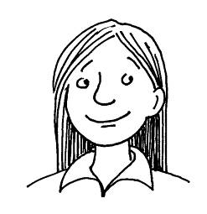
4 |  |  | Grant will be in Blackpool with two friends. He knows there’s a place where you can walk on a glass floor very high up in the air! Can he do it?! He also wants to play lots of video games with his friends and perhaps win a prize. | 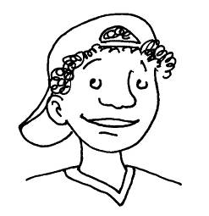
5 |  |  | Pippa loves swimming. She wants to try the world’s longest water roller coaster. But she wants to swim in the sea too. | 

Writing

Task 3a: Where I live. |  | 8 p.
Read the page from this website for teenagers in Europe then write to the website. Write 70-80 words.

WHERE I LIVE
Our readers are from lots of different places and countries and we love hearing from you about where you live. Is it a big city? A small village? What interesting and special things are there in your town or in the area where you live? Write to us and tell us!

I live in Preston in England
Hi! I’m Jacqueline Williams and I live in Preston in England. It’s a town in the north of England. It isn’t big, but it isn’t small. We have lots of shops here, a park, a big cinema and some nice restaurants. Preston is OK, but Blackpool is nicer! Preston is about 20 miles from Blackpool and I often go there at the weekends with my friends. In Blackpool there are lots of interesting things to do. There’s a funfair, the Blackpool Tower, arcades – and, of course, the beach and the sea. In the autumn you can also see the Blackpool Illuminations. They’re great.
Jacqueline Williams (14), England

Wordpower

Task 4a: Electric things. |  | 5 p.
Find words and phrases for the mindmap about electric things. Write ten words and phrases.

Electric things you can find  at home are…  a TV |  | Electric things you can find  in town are…  trams
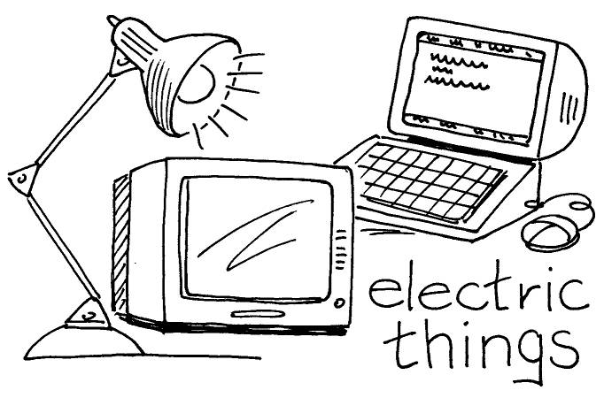
What can you do with electric things?
You can…
watch TV

Task 4b: Read the brochure. |  | 4 p.
Put in the missing words. You’ll need one word twice (=2x)!

me • you • him • her • it • us • them
1 Two tourists: “We want to buy some tickets. Can you help ________________, please?”
2 Don’t waste energy. Save ___________________!
3 Gina: “I think I’ll go to town this afternoon.” Maria: “Great. I’ll come with ____________.”
4 Josh: “Mum! Where are my school books? I can’t find _____________.”
5 Emily: “Our new English teacher Ms Potter likes funfairs! I saw ___________ on the
roller coaster yesterday evening!”
6 Chloe: “Do you like amusement arcades?” Oliver: “No! I hate __________!”
7 “I can do this,” said William. “Watch ______________!”
8 This is Tim in his room. Can you see _____________ in the picture?

Task 4c: |  | 5 p.
Look at the pictures and finish the dialogue.

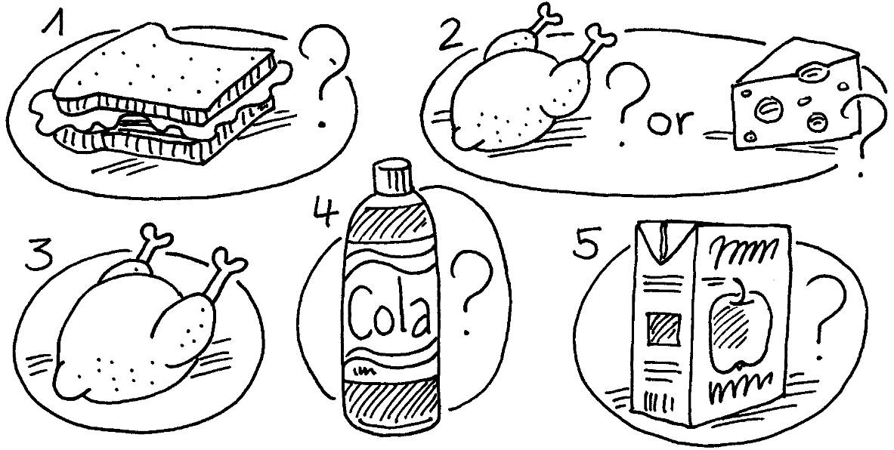

Callum I’ll make lunch. Would (1) ______________________________________?
Thomas Yes, please.
Callum (2) _________________________________________________________?
Thomas (3) ________________________, please.
Callum What about a drink?
Thomas Do (4) _______________________________________________________?
Callum No, sorry.
Thomas What (5) _____________________________________________________?
Callum Sure, no problem. I’ll get it.

Structures

Task 5a: Sophie always helps her friend Daisy. |  | 5 p.
Write in sentences from the box. You don’t need two of the sentences!

I’ll open the window • I’ll make a sandwich • I’ll phone my mum • I’ll help you with it
I’ll come to town with you • I’ll watch TV with you • I’ll buy your ticket

1 Daisy I’m hungry.
Sophie
2 Daisy I’d love to go to the cinema with you, Sophie, but I don’t have any money.
Sophie
3 Daisy I don’t understand this computer game.
Sophie
4 Daisy It’s really hot in this room.
Sophie
5 Daisy I want to buy a new T-shirt in town. Can you help me?
Sophie Sure,

Task 5b: Two friends are talking about technology in the future. |  | 8 p.
Finish the dialogue. Use ’ll, will and won’t.

Ben I think everybody will have (have) robots in their houses. The robots
(1) ______________ (make) all the food and they (2) ______________ (clean)
the rooms.
Max So people (3) ____________________ (not/work) at home.
Ben That’s right. What do you think about the future?
Max I think kids (4) _____________________ (not/go) to school. I think
we (5) __________________ (have) lessons at home on the computer.
Ben Mmmm. That (6) _________________ (be) boring! Kids in the future
(7) ____________________ (not/see) their friends.
Max No problem. They (8) __________________ (talk) to their robots!

Ergebnisse

 |  | erreicht | möglich
LISTENING
LISTENING | Task 1a: |  | 3
LISTENING | Task 1c: |  | 2,5
READING
READING | Task 2a: |  | 5
WRITING
WRITING | Task 3a: |  | 8
WORDPOWER | Task 4a |  | 5
WORDPOWER | Task 4b |  | 4
WORDPOWER | Task 4c |  | 5
Structures | Task 5a: |  | 5
Structures | Task 5b: |  | 8
 | ∑ |  | 45,5

ca. Notengrenzen

Note | % | ab … Punkten
sehr gut | 90 | 41
gut | 75 | 34
befriedigend | 60 | 27
ausreichend | 45 | 20
mangelhaft | 20 | 9

Note

Datum, Unterschrift Klassenlehrer

Unterschrift d. Erziehungsberechtigten

LISTENING | Task 1a: | 3
LISTENING | Task 1b: | 2,5
READING | Task 2a: | 5
WRITING | Task 3a: | 8
WORDPOWER | Task 4a: | 5
WORDPOWER | Task 4b: | 4
WORDPOWER | Task 4c: | 5
Structures | Task 5a: | 5
Structures | Task 5b: | 8
 | ∑: | 45,5
 | Grade:

Listening The Blackpool Illuminations
Announcer
Hello, and welcome to Blackpool. It’s 8 o’clock in the evening here and I’m afraid the weather is very bad. It’s raining. But there are thousands of people here in the street. I can see young people, old people, kids, teenagers … and they all look happy. Today is the first day of the Blackpool Illuminations.
Very soon, all the lights will come on for the first time. OK, here we go …
ten, nine, eight, seven, six, five, four, three, two, one.
Wow! That’s totally amazing! It’s suddenly like day here! There are millions of lights everywhere.
Let’s talk to some people. Sir, madam, excuse me.

Man Hello.
Announcer You’re here to see the Blackpool Illuminations, right?
Man Yes, that’s right.
Announcer Is this your first visit to the lights?
Man Oh no. My wife and I come every year. We love the lights.
Announcer Thanks. And now a teenager. Hi.
Girl Hi.
Announcer Is this your first visit to the Blackpool Illuminations?
Girl Yes. Yes, it is.
Announcer What do you think? Do you like the lights?
Girl Well, I didn’t want to come. I thought the Illuminations would be boring.
But they’re not. They’re great.
Announcer Thanks. And now, excuse me, madam…
Woman Me?
Announcer Yes, hi. Can I ask you … what do you think of the lights?
Woman Lots of people love the lights, I know, but I don’t like them.
Announcer Oh.
Woman They cost thousands of pounds. I think the town is wasting electricity.
Announcer But you’re here to see the lights.
Woman No, I’m not. I live in Blackpool. I’m just getting some fish and chips.

1 Listening The Blackpool Illuminations
1a A 5, B 1, C 6, D 5, E 3, F 2
3 Punkte
2,5 Punkte
1b 1 c), 2 a), 3 c), 4 b), 5 a)

5 Punkte
2 Reading Things to do in Blackpool
1 A H, 2 B F, 3 C D, 4 B E, 5 D G

8 Punkte
3 Writing Where I live
(Lösungsvorschlag)
I live in Ettenheim in Germany
Hi! I’m Christoph Singer and I live in Ettenheim in Germany. It’s a town in the south of Germany. Ettenheim is an old town. There are lots of cafes and shops. It’s near the Schwarzwald - that’s the Black Forest in English. One of the biggest funfairs in Germany is also near Ettenheim. It’s called the Europa Park. It has some great roller coasters!

Christoph Singer (14), Germany
(73 words)

5 Punkte
4a Wordpower
(Lösungsvorschlag)
Electric things you can find at home are...
a computer a mobile phone a charger lights a radiator a DVD player a camera

Electric things you can find in town are…
(street) lights a roller coaster an amusement arcade Illuminations

What can you do with electric things? You can…
listen to music go to school call a friend see when it is dark
charge your mobile write an e-mail

4b
4 Punkte
1 us
2 it
3 you
4 them
5 her
6 them
7 me
8 him

5 Punkte
4c Communication Offers
1 you like a sandwich
2 Chicken or cheese
3 Chicken
4 you have cola
5 about apple juice

Writing The Internet
3a For:
8 Punkte
The Internet is never boring.
You can learn lots of things.
You can make friends.
You can send e-mails quickly.

Against:
People don’t write letters.
People spend too much time online.
Some people copy things for their homework.
You can talk to the wrong people.

3b 1 without
2 from
3 Punkte
3 and
4 but
5 or
6 hours

Wordpower
5 Punkte
4a 1 What a surfer needs: beach, surfboard, wave, wetsuit
2 What a model needs: clothes, make-up artist, photo shoot, photographer
3 What an actor needs: comedy, director, movie, role

4b
1 b
2,5 Punkte
2 a
3 b
4 c
5 b

4c
13,5 Punkte
(Lösungsvorschlag)

Katja, du hast eine Mail von Luke bekommen, dem
Bruder von Jack. Er freut sich, dass du nächste Woche
in LA sein wirst.
Er schreibt, dass ihr Rollschuh laufen und surfen werdet.
Er will dir viele Orte zeigen. Ihr werdet nach Venice Beach
gehen. Dort ist es wirklich cool! Wenn wir ankommen,
sollst du ihn anrufen. Seine Nummer ist 310 212 6742.
Er wartet auf deinen Anruf. Er schickt liebe Grüße.

Structures Past progressive
a 1 were
2 Punkte
2 were
3 was
4 was

b 1 buy: My mother was buying souvenirs.
5 Punkte
2 drive: My father was driving along the freeway.
3 check: My parents were checking our tickets.
4 jog: I was jogging along the boardwalk.
5 scream: My sister and I were screaming on the roller coaster.

5 Punkte
c 1 were
2 were
3 was
4 Was
5 was

1 wasn’t
2 wasn’t
3 wasn’t
4 weren’t
5 weren’t

5a Structures
1 I’ll make a sandwich.
5 Punkte
2 I’ll buy your ticket.
3 I’ll help you with it.
4 I’ll open the window.
5 I’ll come to town with you.

8 Punkte
5b Structures
1 will make
2 ’ll clean
3 won’t work
4 won’t go
5 ’ll have
6 ’ll be
7 won’t see
8 ’ll talk

